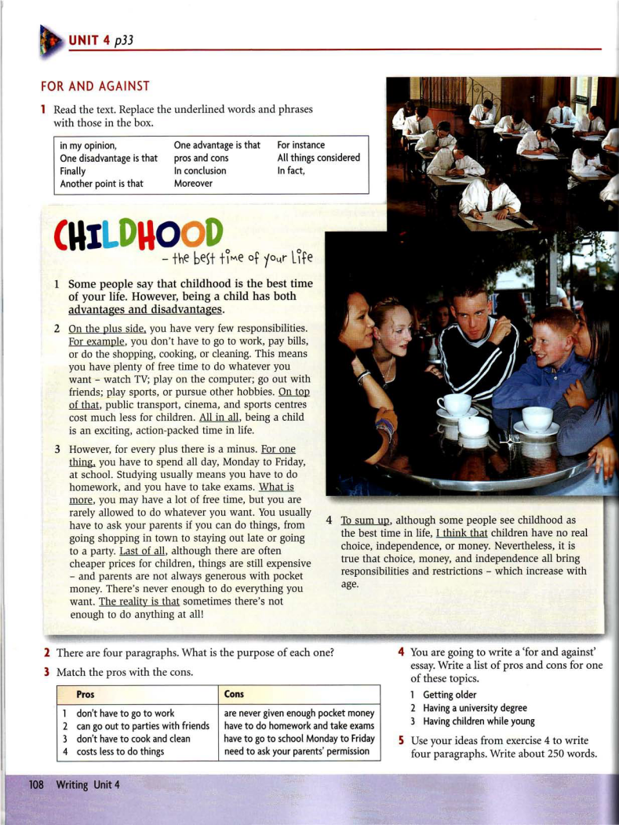

New Headway. Intermediate. John and Liz Soars
https://may.alleng.org/d/engl_en/eng093.htm

