5. Wave Energy Buoy
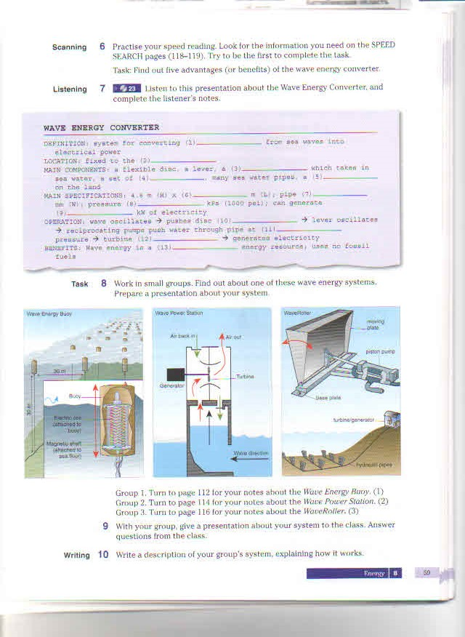
DEFINITION: device / wave energy – electricity
MAIN COMPONENTS: copper coil, magnetic shaft, fiberglass container, cable
LOCATION: copper coil in buoy floats on sea surface; magnetic shaft attached by cable to seabed
MAIN SPECIFICATIONS: buoy 4m (H); 35 m above seabed; 35 m between each buoy; 1.5-3 km from shore; 100 kw power
OPERATION: wave oscillates --- magnetic shaft/ reciprocate (explain to listeners: this means “move up and down”) --- shaft/ move/ through copper coil --- induce/ electric current
BENEFITS: wave energy v wind energy? More reliable; renewable; no fossil fuels
PROBLEM: about 500 buoys needed; could damage ships, fish
VOCABULARY
copper I ['kɔpə] coil I [kɔɪl] медь спираль
magnetic shaft магнитная ось
cable ['keɪbl] канат, трос
buoy [bɔɪ] буй, бакен
induce [ɪn'djuːs] вызывать; стимулировать; приводить (к чему-л.)
reliable [rɪ'laɪəbl] надёжный; верный, испытанный
fossil ['fɔs(ə)l] fuel [fjuːəl] ископаемое топливо
damage ['dæmɪʤ] вред, повреждение; дефект, поломка; убыток, ущерб, урон

6. WAVE ENERGY STATION

DEFINITION: device/convert energy from waves --- electrical power
MAIN COMPONENTS: air chamber, turbine, generator, valves
LOCATION: fixed to the seabed; close to shore
MAIN SPECIFICATIONS: 35 m length x 35 m width; 485 tonnes weight; made of steel; 200 m from shore
OPERATION: wave enters chamber --- water rises and falls in chamber --- water forces air in and out of hole --- moving air makes turbine rotate --- turbine turns generator
BENEFITS: free energy; no fuel needed; no waste produced; not expensive to operate
PROBLEM: noisy; must be able to resist rough weather

VOCABULARY
valve [vælv] клапан; вентиль; золотник; затвор; створка
expensive [ɪk'spen(t)sɪv ] дорогой, дорогостоящий
turbine ['tɜːbaɪn] ; турбина
rough weather непогода, буря, ненастье

7. WAVE ROLLER

DEFINITION: device/change/wave energy --- electricity
MAIN COMPONENTS: base plate, moving plate, piston pump, hydraulic pipes, turbine, generator
LOCATION: base plate fixed to the seabed; hydraulic pipes on seabed; turbine and generator on shore
MAIN SPECIFICATIONS: moving plate approximately 1 m x 1 m; depth 7-15m below sea surface; each plate produces 13 kw power
OPERATION: waves move forward and backward along seabed --- plate oscillates --- pistons move in reciprocating motion --- turbine rotates --- generator produces electricity
BENEFITS: Wave Roller invisible because on seabed; no noise; does not interfere with ships
VOCABULARY
base plate опорная плита
piston pump поршневой насос
turbine ['tɜːbaɪn] турбина
hydraulic [haɪ'drɔːlɪk] Гидравлический
approximately [ə'prɔksɪmətlɪ] приблизительно
8. wave energy converter

