How to format REFERENCES:
- Study the info using the links below
- Pay special attention to APA, MLA and IEEE citation styles!
- Pay attention to Books and Internet resources formatting!
e.g.
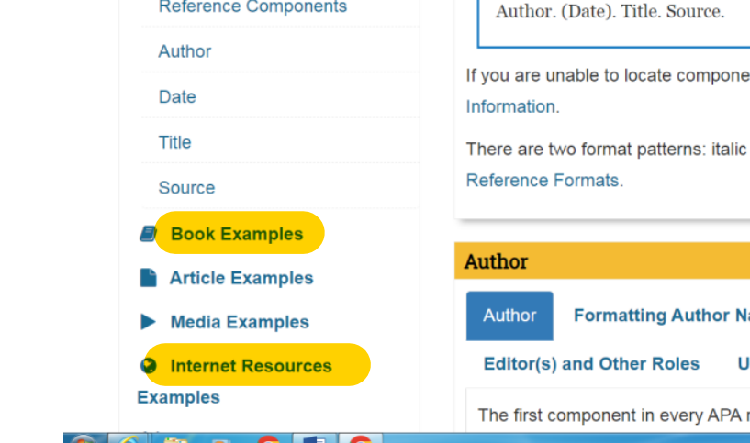

- Choose ONE style for your references
https://pitt.libguides.com/citationhelp
https://owl.purdue.edu/owl/research_and_citation/mla_style/mla_formatting_and_style_guide/mla_works_cited_page_books.html
https://owl.purdue.edu/owl/research_and_citation/mla_style/mla_formatting_and_style_guide/mla_works_cited_electronic_sources.html
https://sfcollege.libguides.com/apa/components
https://sfcollege.libguides.com/apa/internet

