Week 1
Lecture 1
WHAT IS ACADEMIC WRITING

Questions for discussion after the lecture

- What is Academic Writing?
- What is a paragraph?
- Can a paragraph discuss more than one topic?
- What are the three parts of a paragraph?
- Where do you write the title of a paragraph?
- What is indenting?
- What are margins?

The kind of writing you will learn to do in this course is called academic writing because it is the kind of writing you do in college/university classes. Every kind of writing has a particular purpose and a particular audience. The purpose of academic writing is to explain something or to give information about something. Its audience is your teacher and your classmates. Academic writing requires certain skills. These skills include:
- sentence structure (how to arrange words in a sentence),
- organization (how to arrange ideas in a paragraph),
- grammar,
- punctuation.

What is a Paragraph?

A paragraph is a group of related sentences about a single topic. The topic of a paragraph is one, and only one, idea.

A paragraph has three main parts.

1 . Topic sentence The first sentence in a paragraph is a sentence that names the topic and tells what the paragraph will explain about the topic. This sentence is called the topic sentence.
- Supporting sentences The middle sentences in a paragraph are called the supporting sentences. Supporting sentences give examples or other details about the topic.
- Concluding sentence The last sentence in a paragraph is called the concluding sentence. A concluding sentence often repeats the topic sentence in different words or summarizes the main points. A paragraph is like a cheeseburger sandwich: two pieces of bread (the topic and concluding sentences) enclosing the filling (the supporting sentences).
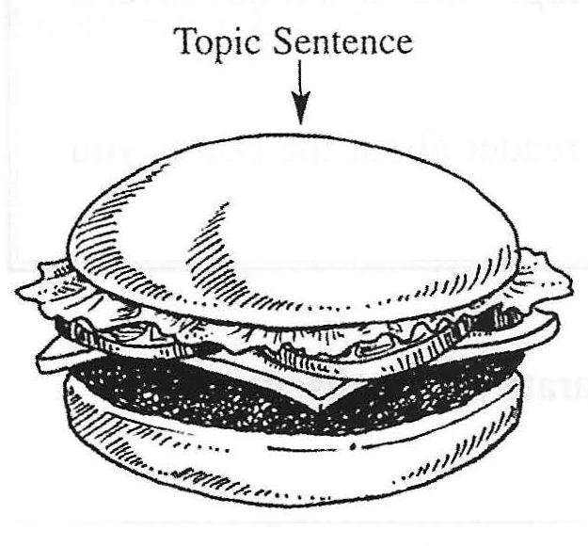
Topic Sentence The most important sentence in a paragraph is the topic sentence. It is called the topic sentence because it tells the reader what the topic of the paragraph is. In other words, it tells the reader what he or she is going to read about. The topic sentence is usually the first sentence in a paragraph.
When you write a paragraph, you need your main idea to be clear.
One way to make your main idea clear is to start your paragraph with a topic sentence. The topic sentence introduces the topic (subject) of the paragraph. It also gives the controlling idea, which is what you want to say about the topic.

Usually, the topic comes first and the controlling idea comes second in the topic sentence. However, the controlling idea may come first. In the a sentences, the topic is first. In the b sentences, the controlling idea is first.

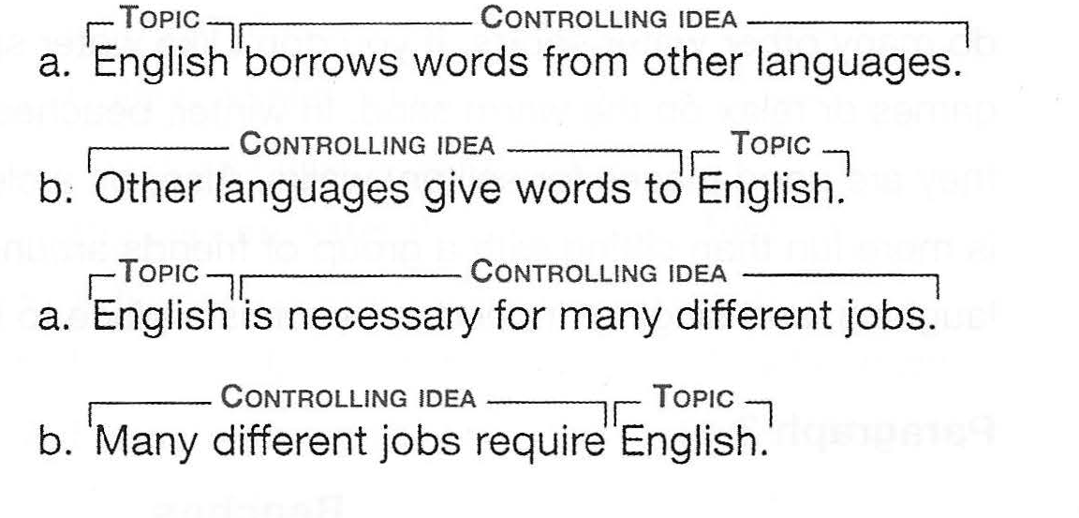

Supporting Sentences come after the topic sentence. Supporting sentences explain or prove the idea in the topic sentence. The supporting sentences are the biggest part of a paragraph.

Listing-Order Transition Signals

A transition signal is a word or phrase that shows how one idea is related to another idea. In a listing-order paragraph, use transition signals such as First, Second, and Third to tell your reader that these are main points. Here are some transition signals that show listing order.

Listing-Order Transition Signals
First,  First of all,  Second,  Third,  In addition,  Also,  Finally, | also  , also.

- Place most listing-order transition signals at the beginning of the sentence, and put a comma after them.
Examples
First, living in a foreign country helps you learn another language faster than studying it at school.
In addition, small colleges are friendlier, so new students make friends more quickly. Also, on a clear winter night, nothing is more fun than sitting with a group of friends around a big bonfire, talking, laughing, and singing.
- Also may come in the middle of a sentence (between the subject and the verb) without a comma or at the end of a sentence with a comma.
Examples
They also like to "hang out" at the beach with their friends.
They like to "hang out" at the beach with their friends, also.

Paragraph Unity
Here is an important rule to remember when you write supporting sentences. A paragraph must follow the rule of unity. All the sentences in a paragraph are about one main idea.

Concluding Sentence
Paragraphs that stand alone (that is, paragraphs that are not part of a longer composition) often have a concluding sentence at the end. A concluding sentence closes the paragraph so that the reader is not left expecting more.
- Sometimes a concluding sentence reminds the reader of the main point by restating the topic sentence in different words.
Examples:
Indeed, a beach is a place to have fun all year.
In short, you have three delicious choices when you order Thai curry.

- Sometimes a concluding sentence summarizes the main points.
Examples:
In short, flight attendants are friendly, self-confident, and strong.
To summarize, employers look for dependable, responsible team players.

Each paragraph that you write should also have a title. A title tells the topic of the paragraph in a few words. A title is short. It is not a complete sentence. It may be just one word. Here are some examples of titles:

Friendship
My Native City
A Famous Soccer Player

As you read the following model, look for the three parts of a paragraph.

Paragraph 1

Mrs. Robinson

1My first grade teacher was an important person in my life. 2Her name was Mrs. Robinson. 3ln the schools in my country, children usually learn to print before they learn to write. 4Mrs. Robinson didn't believe in printing. 5She thought it was a waste of time. 6She taught us to write in cursive script (like handwriting) from the first day. 7At first it was hard. SShe made us practice a lot. 91 remember filling entire pages just with capital Os. 10At the end of the year, we felt very grown up because we could write in cursive. 11Mrs. Robinson was important in my life because she taught me a valuable lesson. 12 I can achieve anything by working hard.

Paragraph 2
My Best Friend

1My best friend, Freddie, has three important qualities. 2First of all, Freddie is always ready to have fun. 3Sometimes we play Frisbee in the park. 4Sometimes we just sit around in my room, listening to music and talking. SWell, I talk. 6Freddie just listens. 7Second, he is completely trustworthy. 81 can tell Freddie my deepest secrets, and he doesn't share them with anyone else. 9Third, Freddie understands my moods. 10When I am angry, he tries to make me feel better. 11When I am sad, he tries to comfort me. 12When I am happy, he is happy too. 13 To sum up, my best friend is fun to be with, trustworthy, and understanding-even if he is just a dog.

To sum up, just remember that a paragraph has three parts.

Paragraph Form

Here is an important rule to remember when you write supporting sentences.

A paragraph must follow the rule of unity. All the sentences in a paragraph are about one main idea.

All the supporting sentences in a paragraph must be relevant. Relevant means "directly related to the main idea." For example, if your paragraph is about your mother's good cooking, a sentence such as My sister is also a good cook is not relevant because the paragraph is about your mother, not your sister. When you write a paragraph, make sure that all of your supporting sentences are relevant. The opposite of relevant is irrelevant.

Here are the rules for correct paragraph form for handwritten paragraphs:

You should put your name (and group), course number (subject), and date. Your paper should have a title and margins.

1. Paper Use 8½-inch-by-11-inch lined, 3-hole paper. The three holes should be on your left side as you write. Write on one side of the paper only.
- Ink Use black or dark blue ink only.
- Heading Write your full name in the upper left comer. On the next line, write the course name and number. On the third line, write the date the assignment is due in the order month-day-year, with a comma after the day.
- Assignment Title Center the title of your paragraph on the first line.
- Body Skip one line, and start your writing on the third line. Indent (move to the right) the first sentence Y2 inch from the left margin.
- Margins Leave a l-inch margin on the left and right sides of the paper. Also leave a l-inch margin at the bottom of the page. Your teacher uses these empty spaces to write comments to you.
- Spacing Leave a blank line between each line of writing. Your teacher uses the space between lines to mark corrections.

Here are the rules for correct paragraph form for a paragraph typed on a computer.

- Paper Use 8½-inch-by-ll-inch white paper.
- Font Use a standard font style, such as Times New Roman. Do not use underlining, italics, or bold type to emphasize words. It is not correct to do so in academic writing.
- Heading Type your full name in the upper left corner. On the next line, type the course number. On the third line of the heading, type the date the assignment is due in the order month-day-year, with a comma after the day.
- Assignment Title Skip one line, and then center your title. Use the centering icon on your word processing program.
- Body Skip one line, and start typing on the third line. Indent (move to the right) the first line of each paragraph by using the TAB key. (The TAB key automatically indents five spaces.)
- Margins Leave a l-inch margin on the left and right margins.
- Spacing Double-space the body.

REMEMBER! Do NOT introduce a new idea in your concluding sentence. Just review or repeat the ideas you have already discussed. Don't add anything new.
Use a transition signal to tell your reader that this is the end of your paragraph. The following chart lists several conclusion signals. Notice that there is always a comma after conclusion signals.

Conclusion Signals
To conclude,  In conclusion, | To sum up,  To summarize,  In summary, | In brief,  In short,  Indeed,

