Тема 9. Архитектура 1970--1990-х годов. Постмодернизм, 1970-1990е годы (Ро-Мо). Постмодернистский классицизм в 1970-2000-е годы. «Maiпstream» постмодернистской архитектуры
Из пестрого потока популистской, радикально-историцистской и радикально-эклектистской архитектуры, с одной стороны, и достижений модернистской архитектуры, с другой стороны, внутри постмодернизма стала складываться доктрина так называемого постмодернистского классицизма, того синтетичного стержневого стилистического направления, к поискам которого призывала архитектурная общественность. Ряду архитекторов удалось создать свои персональные варианты такого синтеза, который обозначал нахождение такого уровня эквивалентности всех используемых средств, который бы давал возможность соединить самые глубинные, фундаментальные законы формообразования, найденные как в древние времена, так и в ХХ в. Был найден уровень абстрактности и конкретности двух рациональных ТКП: 1 и ПI, их совместимости в двойном кодировании, которое привносило неоднозначность, временную многомерность. Постмодернистский классицизм в наиболее цельном своем выражении сформировался к концу 1970-x гг. и победно шествовал по миру до конца 1980-х гг.
В интернете
Наиболее влиятельные архитекторы и фирмы данного направления:
Michael Graves (зрелое творчеL'ВО), Hans Hollein, James Stirling & Michael Wilford (зрелое творчество), Ricardo Bofill, Robert Venturi & Denise ScottBrowll, Charles Moore (Moore, Ruble, Yudell), Arata Isozaki (некоторые проекты), Тепу F'arrell, SOM (некоторые проекты), КРР (некоторые проекты), Philip Johllson (некоторые проекты), Robert A.M.Stem, Rob Krier, Leon Krier, Tomas Taveira, Pei СоЬЬ Freed (некоторые проскты).

Тема 10. Архитектура 1970--1990-х годов. Постмодернuзм, 19701990-е годы (Ро-Мо). Радикальный историцизм в 1970-1990-е годы (неоmрадиционалИ3JИ, неоклассицизм, неоготика и т.д.)
В отличие от радикального эклектизма радикальный историцизм (еще одно направление эпохи реакции на модернизм) более ограничен в своих предпочтениях. Для этого направления характерно более радикальное неприятие всего, что связано с «Современным движением». Это направление постмодернистской архитектуры продолжило развитие нетленных традиций домодсрнистской эпохи в архитектуре, используя все ее средства, наработанные в рамках 1 ТКП, Используя новые технологии лишь как средство достижения уже сложившихея образных архетипов, а не как самодовлеющий принцип, радикальный историцизм
реанимировал множество неостилей (неоклассицизм, необарокко, неоромантизм, неоготика и так далее). Но если раньше каждый из этих стилей был историческим и даже стилем эпохи, то в эпоху постмодернизма неостили стали всего лишь стилевыми поднаправлениями - рядовыми языками одной из нескольких языковых систем. Образность какой-либо модели 1 ТКП берется опять-таки в качестве символа, знака. Этот подход предполагает и свободную возможность эклектики, но в рамках 1 ТКП.
Развитие постмодернизма в 1980-е гг. достигает своего апогея. Самое «леворадикальное» направление историцизма представлено многочисленными историцистскими неостилями.

В интернете
Наиболее влиятельные архитекторы и фирмы данного направления:
Quinlan Terry, Robert Adam, Demetri Porphyrios, Allan Greenberg, Robert Venturi & Denise Scott-Brown (некоторые проекты), Charles Vandenhove, Leon Krier, Rob Krier, Taft Architects, Kipp, Richter & Ass, Harman- Сох Architects, Pierre Fakhoury, Robert A.M.Stem (некоторые проекты), SOM (некоторые проекты), KPF (некоторые проекты).

- Kohn Pedersen Fox (KPF)

Kohn Pedersen Fox Associates (KPF), an architectural firm responsible for several world-renowned buildings, provides architectural, interior and urban design as well as programming and master planning services for clients in both the public and private sectors. KPF is one of the largest architecture firms in the world and is currently the largest in New York City, where its headquarters are located. The firm’s portfolio includes corporate, hospitality, residential, academic, civic, cultural, and mixed-use projects located in more than 35 countries.
Today, KPF’s projects include civic and cultural spaces, commercial office buildings, transportation facilities, residential and hospitality developments, educational and institutional facilities, and diverse mixed-use commercial developments. KPF’s projects over the last 10 years include Roppongi Hills in Tokyo (2003), Unilever House in London (2007), the Mandarin Oriental, Las Vegas (2009), the Stephen M. Ross School of Business in Ann Arbor (2009), the RBC Centre in Toronto (2009), the University of Minnesota Science Teaching and Student Services Center (2010), Centra at Metropark in Iselin, New Jersey (2011), and the Buffalo United States Courthouse (2011). Over the past 5 years, KPF has completed the tallest towers in a number of countries: Shanghai World Financial Center (2008), the tallest in China, Northeast Asia Trade Tower, the tallest in Korea (2010), the International Commerce Centre, the tallest in Hong Kong (2011), Heron Tower, the tallest in the United Kingdom (2011), and Tour First, the tallest in France (2011).
In New York, KPF is presently designing the Hudson Yards Redevelopment Project, a 26-acre site on Manhattan's West Side that is the largest undeveloped single piece of property on the island. Also in New York, KPF is designing NYU's new College of Nursing, Dentistry & Bio-Engineering Institute in collaboration with EYP Architects and the 390,000-square-foot CUNY Advanced Science Research Center, which is currently under construction. KPF recently completed One Jackson Square (2009) and served as Executive Architect for the 10-year phased expansion and renovation of New York's Museum of Modern Art (2005).
Current projects around the world include the Midfield Terminal Complex at the Abu Dhabi International Airport, Songdo International Business District in Incheon, Korea, NYU's Center for Urban Science and Progress (CUSP) in Brooklyn, the 555-meter-tall Lotte World Tower in Seoul, and the 660-meter-tall Ping An Finance Centre in Shenzhen, China.
KPF’s philosophy is firmly rooted in the belief that success is the result of collaboration and dialogue. KPF explains, “A similar sentiment is central to the manner in which we weave our buildings into the environmental fabric." For a firm of its size, KPF takes on an unusually large number of restoration and renovation projects. Examples of this work include The World Bank Headquarters, Unilever House, and the Landmark in Hong Kong. KPF has been recognized for workplace collaboration. KPF’s intranet “Architectural Forum” has been described in Architectural Record as an example of “a resource that contributes to a learning environment through mentoring supporting teams and individuals with new ideas, and sharing best practices”.
Shortly after its founding in 1976, the American Broadcasting Company (ABC) chose KPF to redevelop a former armory building on Manhattan’s West Side to house TV studios and offices. This experience led to 14 more projects for ABC over the next 11 years, as well as commissions from major corporations across the country, including the AT&T and Hercules Incorporated. By the mid-1980s, KPF had nearly 250 architects working on projects in cities throughout the United States. By 1985, even John Burgee (of rival architecture firm John Burgee Architects) called KPF, “The best commercial firm now practicing in the U.S.” KPF’s design for 333 Wacker Drive in Chicago (1983), which was awarded the AIA National Honor Award in 1984, made the firm nationally famous. It remains a Chicago landmark, and was voted “Favorite Building” by the readers of the Chicago Tribune in both 1995 and 1997. In 1986, KPF’s Procter & Gamble Headquarters in Cincinnati, which included an open plan interior design by Patricia Conway, was recognized for its innovative design with the AIA National Honor Award. After its success with these projects, KPF was selected to design buildings including the IBM World Headquarters in Armonk, NY (1997), the Chicago Title and Trust Building in Chicago (1992) and the Federal Reserve Bank of Dallas (1993).
In the 1990s, KPF also took on a larger number of government and civic projects, including the Foley Square U.S. Courthouse in New York (1995), the Mark O. Hatfield U.S. Courthouse in Portland, OR (1996), the U.S. Courthouse of Minneapolis (1996), the Buffalo Niagara International Airport (1993) and the multiple award-winning redevelopment of The World Bank Headquarters in Washington, D.C. (1996).
KPF’s winning entry in the international competition for the World Bank Headquarters, which drew 76 entrants from 26 countries, was the only entry that included the retention of existing structures. KPF’s sensitive design solution for the World Bank, its first D.C. project, set the tone for KPF’s future high-profile international work.
In the 1980s and 1990s, KPF transformed from an American firm known for its corporate designs into an international firm with institutional, government, and transportation commissions in addition to corporate work.
KPF completed the design for two blocks of the large-scale Canary Wharf redevelopment (1987) and the Goldman Sachs Headquarters on Fleet Street (1987–1991). KPF has been selected for projects in the Canary Wharf area through the present day, including the Clifford Chance Tower (2002) to the KPMG’s European Headquarters (2009). KPF’s subsequent work in the U.K. includes Thames Court in London (1998), the Rothermere American Institute at Oxford University (2001) and the master plan for the London School of Economics (2002). KPF’s design for the award-winning Westendstraße 1 in Frankfurt (1992), an early example of mixed-use design, further increased the firm’s international prominence and solidified the firm’s reputation as a progressive global practice. KPF was chosen for subsequent projects throughout Europe, including Provinciehuis in The Hague (1998), Danube House in River City, Prague (2003), the expansion and renovation of the World Trade Center in Amsterdam (2004) and the Endesa Headquarters in Madrid (2003).
KPF’s introduction to the Asian market began with the 4,500,000-square-foot (420,000 m2) Japan Railways Central Towers project in Nagoya (1999). Within 10 years, KPF had projects in Japan, Korea, Indonesia, Thailand, Hong Kong, Taiwan and mainland China. Completed KPF projects in Asia include Plaza 66 on Shanghai’s Nanjing Xi Lu (2001), Roppongi Hills in Tokyo (2003), the Rodin Pavilion in Seoul (2003), the Merrill Lynch Japan Head Office in Tokyo (2004) and the Shanghai World Financial Center (2008), which was named the “Best Tall Building Overall” by the Council on Tall Buildings and the Urban Habitat in 2008.KPF worked with renowned structural engineers, Leslie E. Robertson Associates, to maximize the Shanghai tower’s floor plate and material efficiency by perfecting its tapered form. In addition to this work in Asia, KPF has completed projects in the Middle East including the Abu Dhabi Investment Authority Headquarters (2007) and the Marina Towers (2008), and has worked in South America, Africa and Australia.

KPF
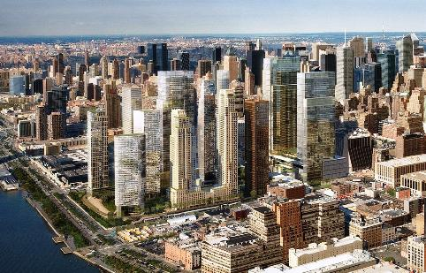  Hudson Yards Redevelopment, New York City, USA | 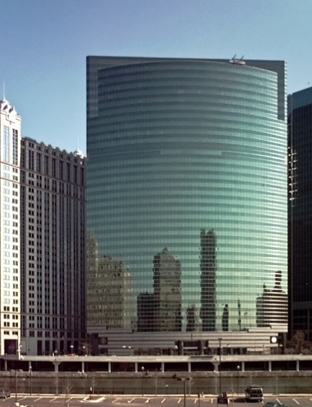  333 Wacker Drive, Chicago, Illinois, USA | 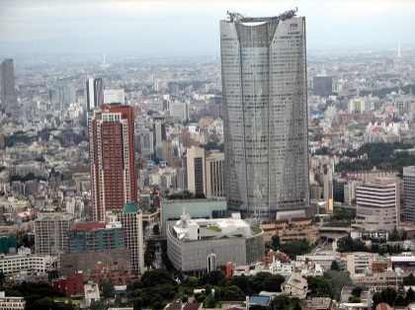  Roppongi Hills, Tokyo, Japan
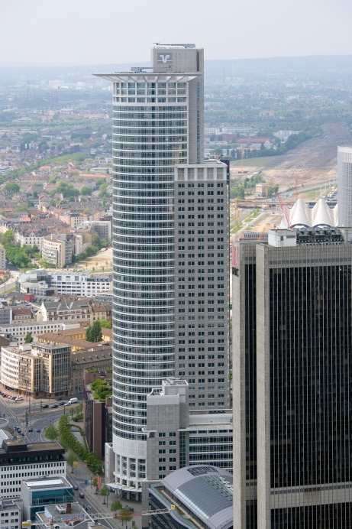  Westendstraße 1, Frankfurt, Germany | 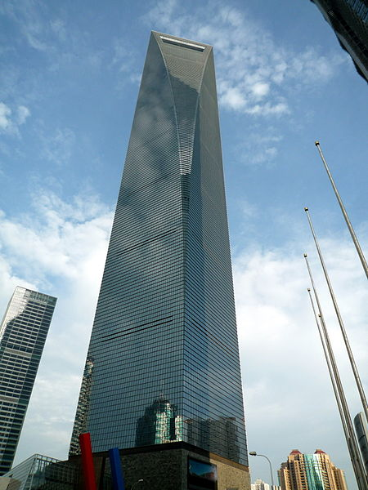  The Shanghai World Financial Center in 2010. | 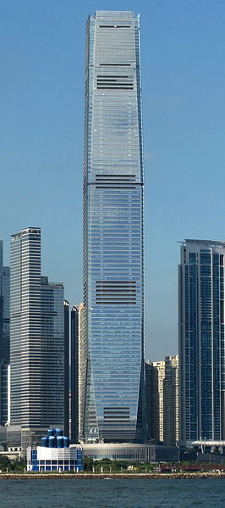  International Commerce Centre, Hong Kong, China SAR

Список литературы в лекции 1

