REVIEW (SENTENCE STRUCTURE, CAPITALIZATION, PUNCTUATION)

SENTENCE STRUCTURE

Command Sentences

Commands Negative Commands

Be quiet. Don’t eat so much!
Wait for me! Don’t forget to call home.
Speak slowly. Don’t worry.

Simple Sentences
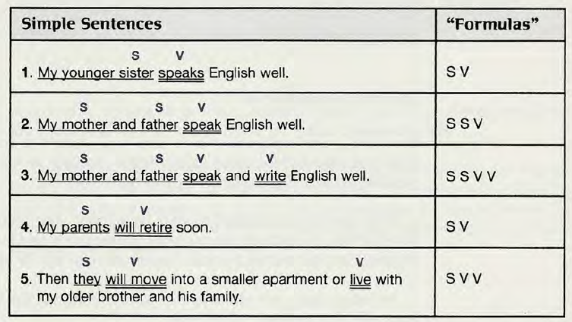

Compound Sentences

Simple sentence, | COORDINATING CONJUNCTION | Simple sentence

 |  | “Formulas”
Simple sentence with compound verb | My family goes camping every summer and usually has fun. | SV V
Compound sentence | My family goes camping every summer, and we usually have fun. | S V, and S V
Simple sentence with compound verb | Last year we went camping but had a terrible time. | SV V
Compound sentence | Last year we went camping, but everyone had a terrible  time.  time. | S V, but S V
Simple sentence with compound verb | Next year we will go to the beach or perhaps stay at home. | SV V
Compound sentence | Next year we will go to the beach, or perhaps we will stay at home. | S V, or S V

Complex Sentences

Simple sentence  (independent clause) | SUBORDINATING CONJUNCTION | Simple sentence (dependent clause)
Water boils if the temperature is 100°C.
SUBORDINATING CONJUNCTION | Simple sentence (dependent clause), | Simple sentence  (independent clause)
If the temperature is 100°C, water boils.

Time Subordinators
after | I will go straight to bed after I finish writing this paragraph.
as soon as | She felt better as soon as she took the medicine.
before | Wait for a green light before you cross a street.
since | It has been a year since I left home.
until | We can’t leave the room until everyone finishes the test.
when | Where were you when I called?
whenever | Whenever I don’t sleep well, I feel sick the next day.
while | My neighbors were having a party while I was trying to sleep.

CAPITALIZATION

Rules | Examples
Capitalize:
1. The first word in a sentence. | My neighbor is a mechanic.
2. The pronoun I. | My friends and I often study together.
3. Names of people and their titles.  but not a title without a name.  Exception: A title without a name is sometimes capitalized if it refers to a specific person. | King Charles, Mr. and Mrs. Homer Simpson  He’s a king.  Have you met your math professor?  The President of the United States had dinner with the Emperor of Japan.
4. Nationalities, languages, religions, and ethnic groups. | Swedish  English  Asian  Muslim  Native American
5. Names of school courses with numbers.  Note: Don’t capitalize school subjects except names of nationalities, languages, religions, and college classes with numbers. | Psychology 101  history  Russian history
6. Specific places you could find on a map. | England  the North Pole  Lake Superior  First Street  New York City
7. Names of specific structures such as buildings, roads, and bridges. | the White House  Highway 395  the Hilton Hotel  State Route 15  the Kremlin  the Brooklyn Bridge
8. Names of specific organizations such as businesses, schools, and clubs. | Sears, Roebuck & Co.  City College of New York  United Nations  Irish Students’ Club
9. Names of the days, months, holidays, and special time periods.  but not the names of seasons. | Monday  New Year’s Day  January  Ramadan  spring, summer
10. Geographic areas.  but not compass directions. | the Middle East  Southeast Asia  the Southwest  Eastern Europe  Drive south for two miles and turn west.

PUNCTUATION

Rules | Examples
Use a comma:
1. After listing-order and time- order signals (except then). | First, put four cups of rice into a pan. After that, fold the paper in half again. After the test, go out and celebrate.
2. Before coordinating  conjunctions in a compound sentence.  Exception: Sometimes writers omit this comma in very short sentences. | Some people like to travel, and others like to have an adventure.  Cook the steak over high heat for six minutes, but don’t let it burn.  Dogs bark and cats meow.  Turn left and drive one block
3. In a complex sentence when a dependent adverb clause comes before an independent clause. | While you are waiting for the pizza dough to rise, make the sauce.  After you take the pizza out of the oven, cut it into eight pieces.
4. To separate items in a series. A series is three or more things. These may be words or phrases (groups of words). | One dog, one cat, two goldfish, a bird, and four humans live at our house.  Every morning I get up early, run a mile, take a shower, eat breakfast, and feed my pets.  Turn left at the stoplight, go one block, and turn right.

