15 LANDSLIDE PROCESSES

What is a landslide? Where do landslides occur? Why study landslides? What's the difference between a landslide and a debris flow?
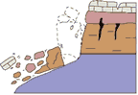
(Public domain.)

What is a Landslide?
The term landslide includes a wide range of ground movements, such as rock falls, deep failure of slopes, and shallow debris flows. Although gravity acting on an over-steepened slope is the primary reason for a landslide, there are other contributing factors:
- erosion by rivers, glaciers, or ocean waves create oversteepened slopes
- rock and soil slopes are weakened through saturation by snowmelt or heavy rains
- earthquakes create stresses that make weak slopes fail
- earthquakes of magnitude 4.0 and greater have been known to trigger landslides
- volcanic eruptions produce loose ash deposits, heavy rain, and debris flows
- excess weight from the accumulation of rain or snow, stockpiling of rock or ore, from waste piles, or from man-made structures may stress weak slopes to failure and other structures
Slope material that becomes saturated with water may develop a debris flow or mud flow. The resulting slurry of rock and mud may pick up trees, houses, and cars, thus blocking bridges and tributaries causing flooding along its path.
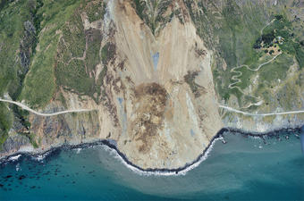
USGS air photo of the Mud Creek landslide, taken on May 27, 2017. (Public domain.)

Where do Landslides Occur?
Landslides occur in every state and U.S. territory. The Appalachian Mountains, the Rocky Mountains and the Pacific Coastal Ranges and some parts of Alaska and Hawaii have severe landslide problems. Any area composed of very weak or fractured materials resting on a steep slope can and will likely experience landslides.
Although the physical cause of many landslides cannot be removed, geologic investigations, good engineering practices, and effective enforcement of land-use management regulations can reduce landslide hazards.
USGS scientists continue to produce landslide susceptibility maps for many areas in the United States. In every state, USGS scientists monitor streamflow, noting changes in sediment load carried by rivers and streams that may result from landslides. Hydrologists with expertise in debris and mudflows are studying these hazards in volcanic regions.

Why Study Landslides?
Landslides are a serious geologic hazard common to almost every State in the United States. It is estimated that in the United States, they cause in excess of $1 billion in damages and from about 25 to 50 deaths each year. Globally, landslides cause many billions in damages and thousands of deaths each year.

Additional Resources
- A Homeowner's Guide to Landslides for Washington and Oregon - Washington Department of Natural Resources and the Oregon Department of Geology and Mineral Industries

What is a Debris Flow?
Debris flows, sometimes referred to as mudslides, mudflows, lahars, or debris avalanches, are common types of fast-moving landslides. These flows generally occur during periods of intense rainfall or rapid snowmelt. They usually start on steep hillsides as shallow landslides that liquefy and accelerate to speeds that are typically about 10 mph, but can exceed 35 mph. The consistency of debris flows ranges from watery mud to thick, rocky mud that can carry large items such as boulders, trees, and cars. They are among the most numerous and dangerous types of landslides in the world. They are particularly dangerous to life and property because of their high speeds and the sheer destructive force of their flow.
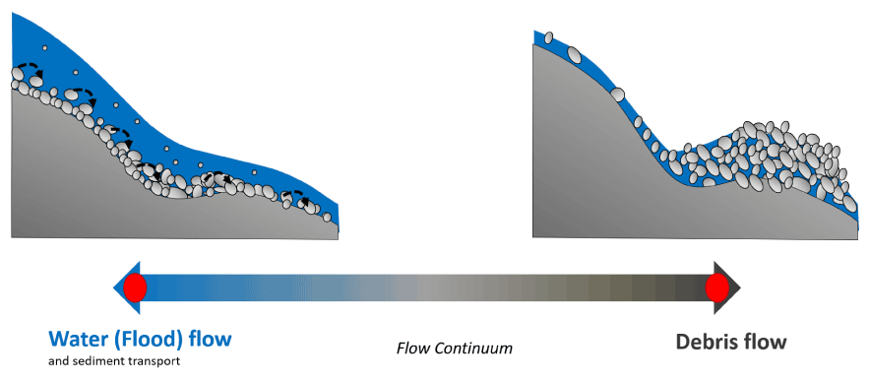
Continuum of flood and debris flow characteristics. (Jason Kean, USGS, Public domain.)
Vegetation and soil changes after a fire increase the runoff and erosion in a watershed, and significantly increase the likelihood of debris flows and flash flooding. Flash flooding and debris flows can initiate during even moderate rainstorms over burn areas and often occur with very little warning. Post-fire flow can alternate between flood and debris flow​. Debris flows are more dangerous and more destructive and dangerous than floods because:
- 10-50 times greater peak discharge
- flow height up to 5 times greater
- flow velocity same or greater
- greater than 50% sediment content
- coarse-grained surge fronts
Distinguishing between debris flow and flood deposits can be difficult, but certain sedimentary structures and textures can give clues to the mechanism of deposition. The following provides more details on the differences.

Comparison of Debris Flows and Floods
Characteristic | Debris Flows | Floods
Grain size | Clay to boulder, greater 50% of sediment is sand-size or greater | Clay to boulder
Sorting | Extremely poor | Moderate to good
Grain shape | Angular to subangular | Round to subround
Texture | No bedding, normal or inverse grading is common, matrix-supported | Distinct planar to cross-laminated beds and laminae voides are common between larger clasts
Sedimentary structures | Levees, terminal lobes, fans, coarse clasts on surface, sandy mud coatings on boulders, logs, banks | Dunes, ripples, and longitudinal bars are common, imbricated gravel clasts
Sediment load | 40-50% sediment by volume, greater than 50% of sediment load is sand-size or larger, sediment load controls flow behavior | 5-10% sediment by volume, water controls flow behavior
Grain Size and Sorting
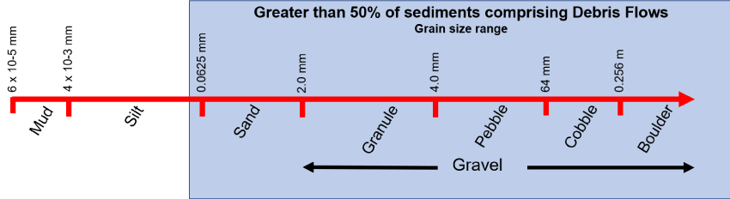
The continuum at the top shows how grain sizes are categorized – greater than 50% of the sediments in a debris flow are in the categories from sand all the way up to boulders. (Jaime Kostelnik, USGS. Public domain.)
Debris flows are capable of transporting material or grains that range from very fine mud- or clay-size particles to boulders that are as large as cars. This wide variation in grain size results in accumulations or deposits of material at the outlet of a drainage basin that are poorly sorted, or in other words, all mixed up together.
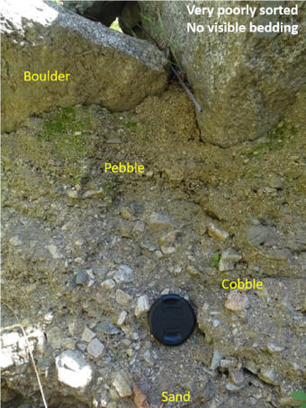
A poorly sorted debris flow deposit with grains ranging from sand-size to boulder size. Camera lens cap near the bottom of the picture for scale. Van Tassel Canyon, Azusa, California. (Credit: Matt Thomas, USGS. Public domain.)
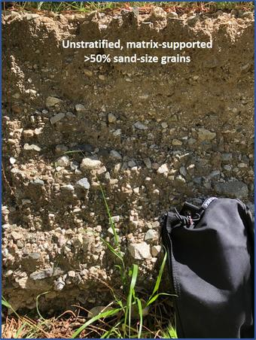
Grains in a debris flow deposit are randomly oriented and no layering is evident. The deposits are matrix-supported, meaning that the spaces between pebbles, cobbles, and boulders are filled with finer sand grains and mud particles. Van Tassel Canyon, Azusa, California. (Credit: Francis Rengers, USGS. Public domain.)
Sedimentary Structures
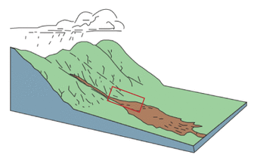
Cartoon of a debris flow with the red box indicating where the levees are located. (Public domain.)
Levees, or ridges of coarse cobbles, boulders and even tree trunks, often line channels that debris flows have passed through. Levees in the images to the right contain pebble to boulder-sized rocks and a tree trunk that has been stripped of its branches and is aligned parallel to the axis of the channel.
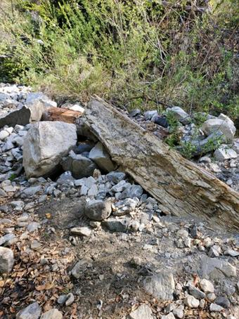
Debris flow levee deposits in Dunsmore Canyon, Glendale, California. (Credit: Francis Rengers, USGS. Public domain.)
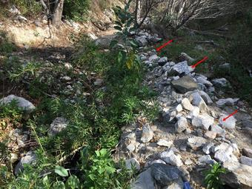
Debris flow levee deposits in Dunsmore Canyon, Glendale, California. (Credit: Francis Rengers, USGS. Public domain.)
As debris flows move from steep, mountainous terrain to gently sloping or flat terrain, they slow down considerably, causing sediment to settle out and form fan-shaped deposits. Alluvial fans formed by debris flow are also poorly sorted and lack any kind of layering or stratification.
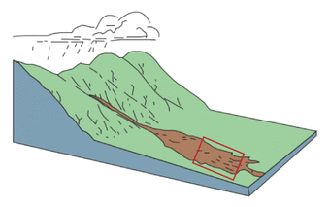
Cartoon of debris flow with red box showing location of fan deposits.(Public domain.)
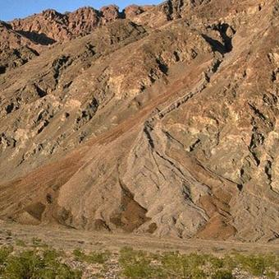
Unnamed debris flow fan on the east side of Death Valley, below the Funeral Mountains between Badwater and Mormon Point, California. (Credit: Dennis Staley, USGS. Public domain.)
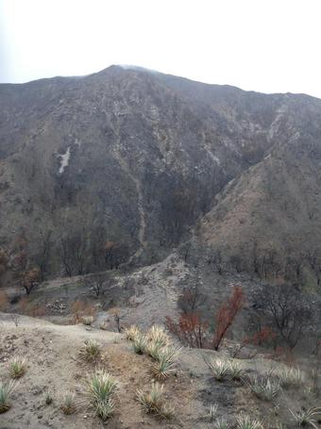
Big Tajunga Canyon, Station Fire, California. Credit: Dennis Staley, USGS. Public domain.)

