13 SOILS AND ENVIRONMENT

Soil is undoubtedly one of the most important components of the environment, yet itis perhaps one of the most undervalued, misused and abused of the Earth’s resources.Lying at the interface of the geosphere, hydrosphere, biosphere and atmosphere, soilsrepresent the end product of a complex set of interacting processes, operating over avast range of time-scales. To a large extent soils determine the agricultural potentialof an area, they influence many geomorphological and hydrological processes, andthey also feature strongly in many aspects of rural and urban planning, includingmineral extraction, construction, waste disposal and conservation. An understandingof soils within an environmental context is therefore important to many disciplines,and this is increasingly the case as environmental problems, such as pollution,acidification, erosion and climatic change, become a matter of increasing publicconcern.
In many academic bookshops you may find at least half a dozen books dealing withvarious aspects of soils within an environmental context, so why another to add tothe problem of choice? The answer lies in the fact that existing texts tend toconcentrate on particular areas of the subject, some at an elementary level andothers in a more advanced way, rather than providing the breadth of coverage whichmany students of environmentally related subjects are likely to encounter during thecourse of their training. It is therefore our intention to provide a wide range ofmaterial which is presented in such a way that it can be used by students in a varietyof environmentally based subjects and at a variety of levels.
Supporting rooted plant life: Solid Earth materials altered by physical, chemical, and biological processes
- •Land-use planning: Soil suitability is large part of land capability
Waste disposal: Soil properties are critical
- Impact of natural hazards: Affected by soil properties
- Climatic signal: clues to the past climate

Soil profiles:
- Weathering
- Physical and chemical breakdown of rocks
- Residual soil
- Transported soil
- Soils are open systems

Soil horizons:
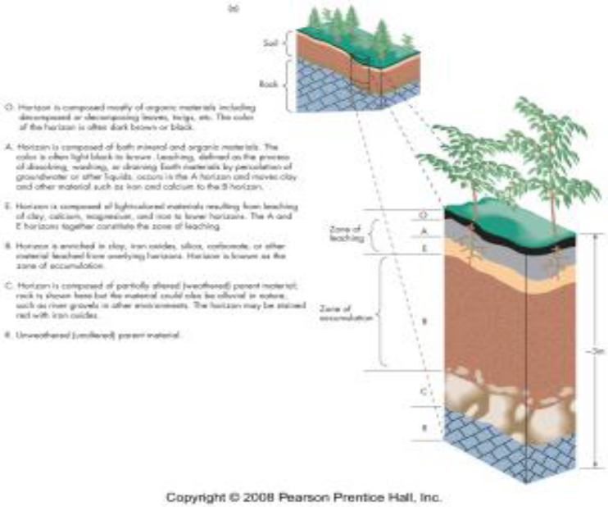
- Movement of materials in soil creates distinct horizons parallel to the land surface

Figure - 15 Soil profile consists of soil horizons

Soil profile consists of soil horizons:
- –O horizon
- –A horizon
- –E horizon
- –B horizon
- –C horizon
- –R horizon
In this topic we examine the constituents and properties of soils, the processes andpathways of soil formation, and the range of soil types and their classification. Theenvironmental factors that influence their development and the resultingcharacteristics of soils at the global scale are then addressed. We go on to discuss theinfluence of past environmental conditions on soils, the role of soils in reconstructingand dating past environments, and soils as components of natural environmentalsystems. Finally, we concentrate on soil-human interactions through theconsideration of soils in landuse systems, soils and environmental problems, and soil.

