11 GEOLOGICAL ACTIVITY OF UNDERGROUND WATER

Underground water includes all nater water, located under the Earth surface in a movable state. Issues of origin, movement, development and distribution of underground water are the subject of studying special branch of geology– hydrogeology. Underground water closely related to atmospheric water and ground hydrosphere – oceans, seas, lakes and rivers. In nature, there is a continuous interaction of these waters, the so-called hydrological cycle.
Water in the earth crust may be in the vapor, liquid and solid states. There are: bound and free water. Bound water is divided into constitutional, crystallization and hydration. Free water is divided into hygroscopic, film, capillary and gravitational. One of the most important factors determining the conditional beginning of the cycle is the evaporation of water from the oceans, seas and the entry of moisture into the atmosphere. The highest moisture into the atmosphere is due to the evaporation of the oceans.
All rocks are to some extent able to pass water, however the degree of permeability is different. By the degree of permeability the rocks are divided into three groups:
1) permeable (coefficient of filtration K_{f}>1 m/day): gravel, gravel, pebbles, sand, any highly fractured monolith (rock) rocks;
2) poorly permeable, or semipermeable (K_{f} = 1–0.001 m/day): sandy loam, light loam, loess, undecomposed peat, slightly fissured rocks;
3) waterproof or impermeable (K_{f} <0.001 m/day): calys, heavy loam, infractured rocks, and rocks in the zone of permafrost.
In the earth crust rocks of first and particularly second group act as reservoirs (storage) of underground water, and rocks of the third group – their underlying aquitard.
Among other water-physical features water capacity of rocks is important, that is, their ability to contain and hold in itself a certain amount of water at a given temperature and pressure.
By origin there is infiltration, sedimentation, juvenile and mixed underground water. Chemical composition of underground water depends on concentration of hydrogen ion: normal water, acid and alkaline. Main chemical components of underground water: chlorine ion, sulfate ion, carbonate and hydrocarbonate ions, alkali and alkaline earth metals, oxides of sodium, calcium and magnesium, colloidal iron and silica. In water, dissolved gases – carbon dioxide, hydrogen sulfide, methane and etc. By total salinity there are (fresh – up to 1g/l, mild salted – 1–5 g/l, brackish 5–10 g/l, salted 10–50 g/l, brines 50 g/l and more).
In conditions of bedding there are usually four types of groundwater: soil, vadose, groundwater and interstratal (fig. 6.7).
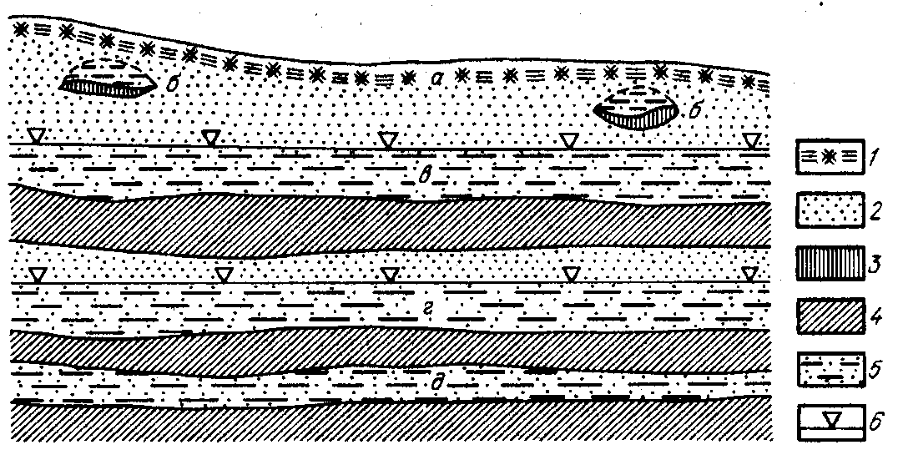
Fig. 6.7. Scheme of location of various types of underground water in earth crust: а – soil water; б – perch; в – ground water; г, д – interstratal water; 1 – soil-vegetative layer; 2 – водопроницаемые rocks; 3 – полуводопроницаемые rocks; 4 – waterproof; 5 – gravitational water; 6 – level of ground water (LGW)

Soil water is distributed in the soil near the surface of the Earth. Their formation associated with the processes of infiltration of precipitation, снеготалых water and atmospheric moisture condensation.
Vadose is formed in the zone of aeration, when infiltrating water on its way meets the lens of waterproof rocks. This can be lens of clays among sandy deposits of river terraces or loam in permeable water-glacier deposits and etc. Underground water of vadose is usually formed at relatively shallow depths and are limited in size distribution. Thickness of rocks, saturated with vadose, most often up to 1 m, rarely reaches 2-5 meters. Greatest thickness is marked in spring in intensive snowmelt and in autumn with abundant atmospheric precipitation. In dry years, the thickness and amount of vadose water decrease, and sometimes it is completely dry out. Persistence of vadose also depends on size and power impermeable bed, water capacity of rocks and feeding conditions. The larger size and thickness of waterproof lens and the intensity of the power, the more terms of vadose existence.
Groundwater. Penetration of rainfall deep into the earth's crust occurs as long as the water does not reach the roof of the first impermeable layer. Atmospheric water, seeping from the top down to the aquitard, and then, moving in the horizontal direction, gradually fill all the voids of rock. So there are aquifers.
Aquifer is rock formation or layer in which the pores, cracks and voids are filled with water. Each such layer has roof and floor. If the layer is not completely filled with water, then the aquifer is understood as only its water-saturated part. The first of earth surface continuous aquifer is called groundwater tables. Groundwater has free surface – mirror, or groundwater table (GWT). This level is unstable. Usually it increases in rainy and decreases in arid periods. If the level of groundwater at some site rises to the earth's surface, there is formed a swamp.
Interstratal (stratal) water. Difference of interstartal water is primarily in the fact that they are enclosed between the two aquitards, i.e. limited by them both on the top (roof side), and bottom (the part of the sole). Aquifers, containing interstratal water, are usually characterized by extensive common areas, often measured in thousands of km². However, they lie at a considerable depth, exiting on the surface only in the periphery. Such an extensive area of interstratal distribution is called hydrogeological basin (fig. 6.8).
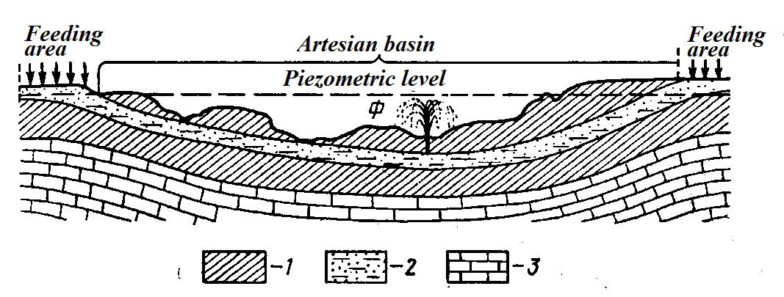
Fig. 6.8. Scheme of artesian basin: 1 – clayey rocks; 2 – aquiferous sands; 3 – limestones; Ф – gushing well

Depending on conditions of occurence, underground water is divided into pressure and non-pressure. While opening the horizon of pressure water by well or a natural way, the water rises to a certain level, corresponding to piezometric levels (PML). Pressure water may have local pressure and artesian.
Output of underground water to the surface of the Earth is called the source or a spring. There are depending on origin vadose, juvenile and mixed sources. By chemical composition, sources are divided into ferrous, alkaline, salty, bitter and salt, sulfur, lime and etc.
Geological processes and phenomena, related to activity of underground water: suffusion, karst, quicksands, landslides, mud volcanism. Rocks, in which these processes develop: limestones, dolomites, gypsum, rock salt. There are surface karst and underground karst.
Karst is a process of dissolution or leaching of soluble fractured rocks by underground and surface water, resulting in the formation of the depressions negative landforms on the Earth's surface and various cavities, channels and caves in depth (fig. 6.9). The first time such well-developed processes have been detail studied on the Adriatic coast, on the Karst plateau near Trieste, from which it got its name. Soluble rocks include salts, gypsum, limestone, dolomite, chalk. In accordance with this they distinguish hydrochloric, gypsum and carbonate karst. The most studied is carbonate karst, which is associated with considerable areal extent limestones, dolomites, chalk.
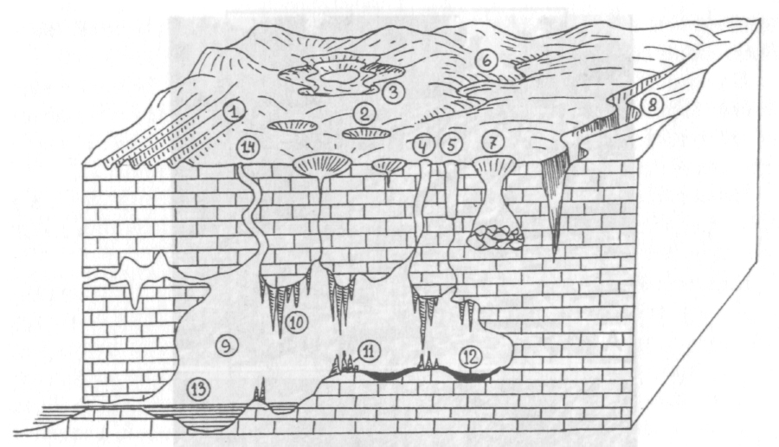
Fig. 6.9. Karst forms of relief: 1 – ditches, 2 – funnels, 3 – cloak, 4 – wells, 5 – mines, 6 – disappearing rivers, 7 – falling funnels, 8 – ravine, 9 – cave, 10 – stalactites, 11 – stalagmites, 12 – «terra-rossa», 13 – cave lake, 14 – siphons

Necessary conditions of karst development are: 1) presence of soluble rocks; 2) fracturing of rocks, providing the penetration of water; 3) dissolving power of water. The greatest diversity of karst forms are observed in the open type of karst (mountain areas of limestone plateau of Crimea, the Caucasus, the Carpathians, the Alps and etc.). In these areas development of karst is favored by open surface of soluble rocks and often showers.
Surface forms in open type of karst are described in detail in general geomorphology, here we dwell only on their short listing and consider the hydrodynamic zone in karstic massif. Surface karst forms include ditches, поноры, sinkholes (surface leaching, failing), large karst depression at the bottom of which sinkholes, полья, karst wells and mines, in places reaching a depth of over 1,000 m can develop.
Underground kast forms include various cahnnels and caves. Deposits in caves are presented by several genetical ypes: 1) insoluble products or residual (from dissolving) formation – terra-rossa; 2) landslip accumulation – products of the collapse of karst cavities vaults; 3) alluvial deposits formed by underground rivers; 4) lacustrine sediments; 5) chemogenous formations – lime tufa (travertine) and 6) dripstones – stalactites, growing from the cave roof down, and stalagmites, growing up. There are also known ice caves, which accumulate various forms of growing up ice.
Level and character of karst arrays of soluble rocks depend on the hydrodynamic conditions. In assessing an array of karst it is important to know the geologic history of the region.
Suffusion – process of mechanical removal by underground water the solids from different rocks (clay, sand, unconsolidated sandstone), that can lead to dips of different sizes.
Displacement of rocks on steep slopes are very different both in nature and in scope. Particularly, there are small deisplacements or mud-stream, big displacement or landslides, and the sudden collapse of the massive amounts of rocks or avalanches, which usually occur in mountain areas. The most important are landslides, which are widespread in nature. Landslide – the natural movement of the rock mass under the influence of gravity, as a result of underground water and at presence of plastic clays in section of horizons. In the undisturbed state such clays do not differ from ordinary. However under mechanical stress and moisture, they acquire high ductility.

Control questions:
- In which phase is the water in rocks?
- What is porosity and permeability of rocks?
- How is underground water divided by its origin and conditions of occurrence?
- What is the difference between groundwater and vadose and artesian water?
- What are karst and suffusion?
- What sediments are deposited by underground water?
- What is the landslide nature?

