10 ACCUMULATION ACTIVITY

Geological activity of glaciers

Glaciers – moving natural clusters of ice of atmospheric origin on earth surface. They are formed in those areas, where the solid precipitation is deposited more than thawed and evaporated. Within glaciers there are area of nutrition and ablation (decrease). Total area of modern glaciers is about 16.3 mln km² (10.9 % of land area), total volume of ice is about 30 mln km³.
Glaciers consist of the so-called glacial ice. Unlike other types of ice (soil, river, sea), arising from the freezing of water, glacial ice is formed of pressed snow – firn.
Necessary condition of glacier formation is the combination of low air temperatures with lots of solid precipitation. Glaciers form above the snow line, where are located nutrition (accumulation area). But while moving glaciers are located below the snow line in the area of ablation (Lat. ablatio – abscission, demolition), where is a gradual decrease in the mass of a glacier by melting, evaporation and mechanical destruction. This zone is sometimes called drain region or unloading area. In the case of a significant strengthening of the power and the excess of its melting, the ice edge moves forward – glacier occurs, in the reverse ratio glacier retreats. Sometimes process of glacier movements is very fast, glacier pulsates. With long-lasting ratio of nutrition and ablation of the edge of the glacier takes a stationary position. Modern glaciers cover an area of over 16 million km², or about 11 % of land.
Geological activity of glaciers, as well as other exogenous factors, includes destruction of rocks (exaration), transport of debris and their deposition. Glacial studies structure, development and activity of glaciers.
Types of glaciers. There are mountain-valley (because they are related to mountain relief, occupying the valley with a characteristic trough-shaped transverse profile, the so-called trogs), coverslips and offshore. Splinters of the glaciers, empty swimming in the sea, are called icebergs.
Speed of movement of glaciers is usually low, averaging from several dozen to several hundred meters per year. However there are cases of very rapid movement of glaciers. As a result of glacier movement surface, on which it is moving, meets with exaration.
Denudation (trogs, mutton foreheads, curly rocks), accumulation drumlins, kama, eskers, zanders are related to glacier forms. Glacier sediments are called moraines. Moraines are: surface, side, middle, bottom and end; their composition is from loam to boulders. Moraines are unsorted, they contain pebbles and boulders of glacial scars and polishing; fluvioglacial sediments.

Fluvioglacial processes. Geological activity of glaciers involves not only the ice, but also melt water formed during the ablation of glaciers. Melt water also includes the entire volume of the surface runoff, coming to the glaciers from the surrounding areas.
In the areas of accumulation of glacier melt water often seeps through unconsolidated snow and porous firn and freezes at a depth; in areas of ablation it usually feeds surface waters, operating during the summer season. Here, like ordinary surface water, are allocated plane and the channel run, just a surface decline is due to its melting, not erosion. At the edge of the glacier, due to a steep longitudinal slope of surface and low roughness of channel walls, water flow rates can be extremely high. On cracks the surface flows can go deep into the glacier where the melt water, encased in tunnels and mines, experiences a large hydrostatic pressure. Due to this it has such a high energy that is able to move against the bed slope and develop channels on slopes facing towards the river.
No matter which channels (onglacial, inglacial, subglacial or marginal) flows of melt water move, their leading feature is impermanence. First of all, it is determined by the mobility of ice. During the movement of ice there is change of crevasses system and their relationship with the adjacent rock surfaces; in this case one flow channel is closed and other becomes available for water. Variability of water courses is also due to the variability of melt flow rates, which are affected by seasonal and diurnal variation of melting rate. The main consequence of the volatility of channels and fluctuating costs is a sharp uneven flow rates, which in turn has a decisive influence on erosion, transport and accumulative work of flows. All processes, carried out by meltwater, are called fluvioglacial.
Numerous glacial dammed lakes are formed at the edges of glaciers. Most typically, they occupy the lower parts of the valleys, the tributaries, dammed by large glaciers of main valleys. Less frequently, they are located in the main valleys, baffled by glacial tongues come to the fore of the side valleys. Besides, dammed lakes can occupy depressions between the glaciers front and moraine ridges associated with past glacial shifts.
Fluvioglacial transportation and accumulation. Flows of meltwater, following on the surface of the glacier, usually carry different amounts of sediment: they can be very clear on the ice sheet or near the center of the valley glacier, and at the beads include a significant amount of material washed down from the side moraine. Streams escaping from under the ice, usually heavily loaded by detrital material, the bulk of which consists of inglacial and subglacial moraine, captured by water from the tunnel walls. An additional source of debris is products destruction of eroding the bed. Sizes of moving debris vary from the boulders to fine silts and clays.
A variety of ways to the drain determines the diversity of environments in which there are fluvioglacial deposits. In their classification we should distinguish material, formed in a direct contact with the glacier, that is on the surface of the ice, in ice and under the thickness and прогляциальный material, deferred out of glacier. The fields of both types of deposits are often combined.
Glacier- lacustrine deposits make up the delta-glacial terrace of kame complexes, a significant portion of normal kams and thickness of the tape clays - clearly stratified sediments, consisting of a large number of parallel strips. Each of such stripes is a result of year cycle of sedimentation in cold lakes, are most of the year in the frozen state. It consists of two layers: darcolored upper - winter, formed under ice cover, clayey composition and the lower summer, formed in high season of ablation, mostly light-colored and tonkopeschanogo.
Glaciation of the Earth's crust. Analysis of geological history of the Earth shows that different areas of present continetns at the certain time were under strong ice sheet. A detailed study of glacial deposits has allowed to establish the most important property of glaciation of the Earth's crust – their frequency. Periods of glaciation in geological history of the Earth alternated with interglacial epochs. Almost all continents of our planet in different time largely (or wholly) were covered by powerful glaciers.
The study of the isotopic composition of oxygen in the section of the Greenland ice shows that the last time of the Earth's crust glaciation was 10-50 thousand years ago. During the last 400 thousand years at least five decreases of temperature at 6–8°С were set, which, apparently, correspond to periods of glaciation of the Earth's crust. During the Quatemary in Western Europe four glacial epoches are allocated: gunz, mindelian, rissian and wurmian. The largest by its area was rissian glaciation.

6.8. Geological work of seas and oceans

Water of ocean is in constant motion under the influence of various forces: cosmic, atmospheric, tectonic and etc. The most pronounced are surface ocean currents, mostly of wind origin. The currents that change its power from season to season, depending on the direction of the coastal monsoon, are called monsoon. There are trade-wind, meridional currents in the oceans.
As the World Ocean it is understood the whole body of water on the Earth, contained in the seas and oceans, connected to each other. Its volume is about 1.5 billion km³ (cube with an edge of more than 1000 km). Water of the World Ocean cover more than 2/3 of the Earth’s surface. This causes the importance of studying the geological sea activities, as one of the most important exogenous factors. Science, engaged in the study of the oceans and seas, is called oceanography.
Changing the mutual arrangement of the Earth and the Moon causes in the World Ocean tides. Ocean is almost always in motion. One of the most striking of its expressions is wind waves. There are typhoons, tsunamis in oceans. In the surf zone rocks of coasts are exposed to destruction – abrasion.
Most of the ocean floor is a smooth surface, the so-called abyssal plains. Their average depth is 5 km. In central parts of all oceans there are linear uplifts at 1–2 km – mid-ocean ridges (MOR), which are connected in a single network. The ranges are divided by transform faults into segments. There are lots of single mountains on the abyssal plains, part of which protrudes above the surface of the water in the form of islands. Most of these mountains are extinct or active volcanoes.
Underwater continental margin consists of a shelf (shallow), the continental slope and the continental foot.
Shelf girds continental land. He is represented by underwater plain with a slight slope. There are towering rocky outcrops above the plain. Depth of shelf is an average of about 130 meters. The formation of the shelf topography is significantly affected by the global glaciation. In this era on land ice masses were formed, and the sea level decreased. Thus, deltas, abrasion platforms were formed in the current areas of the shelf. In areas of the shelf, in the land of the former ice age, archaeologists found the objects of human life and the bones of mammoths.
The boundary between the continental shelf and slope (brow) is, as a rule, clear. The angle of the continental slope inclination is up to17°. Inclination usually has a stepped profile, ledges alternate with horizontal steps. It has accumulation of sedimentary rocks formed by turbidity currents and landslides.
The ocean bed has a depth of 3.5 to 6 km. Its relief is flat or hilly. There are also seamounts; some of them are of volcanic origin. Deep trenches have a depth of 7-11 km. They are especially numerous in the Pacific Ocean. Here is the deepest Mariana Trench. There are trenches also in the Indian and Atlantic Oceans.
Abyssal plains, in most cases, are significantly removed from continents and other sources of demolition, therefore deposits resulting from erosion of the continents are missing on the abyssal plains. Abyssal plains are located at great depth, often more than the carbonate compensation depth – depth below which calcite dissolves, therefore on them there is no precipitation of carbonates and shells of marine organisms, plunging from the upper layers of the ocean are also completely dissolved.
Because of these two reasons in the abyssal plains very typical deposits accumulate – ocean red clay. The rate of accumulation is very low – a few centimeters per thousand years.
There is accumulation of iron-manganese nodules consisting of iron and manganese hydroxides in addition to clay on the abyssal plains. The mineral composition of nodules is dominated by hydroxides of manganese (todorokite, birnessite, бузерит, asbolan) and iron (vernadite, hematite, feroxyhyte). On the tops of guyots and slopes of seamounts, accumulation of manganese and iron minerals goes in the form of ore crusts (fig. 6.10).
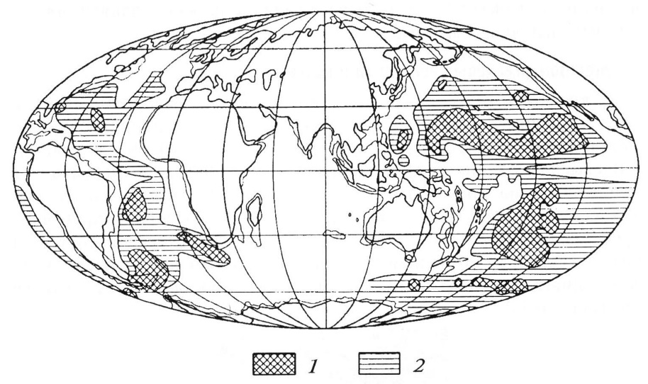
Fig. 6.10. Distribution of ferromanganese nodules in Pacific and Atlantic oceans according to [8]:
1 – dense cover of the bottom by nodules, in places by 90 %; 2 – nodules often occur, although they are unevenly distributed

Red sludges are also composed of pelitic dimension particles. Their color is due to the presence of iron oxide minerals (limonite, hematite). Such sludge is formed in seas, adjacent to continents, where red-colored weathering crusts are developed, particularly, off the coast of Brazil, in the Japan Sea, in the south-eastern part of the Black Sea. Distribution of red sludge, thus, is of local character. Spread on the ocean floor ferromanganese nodules that contain copper, nickel, cobalt, molybdenum and etc. is associated with deep red clays (fig. 6.10).
The study of deep-sea bottom sediments shows that their color is not accidental, but reflects the features of the environment of their formation.
In the rift zones of the oceans high-temperature (up to 415^{о}С) ore-bearing solutions were found, opening onto surface of the bottom of the depth of 2-3 km and forming sulphide deposits. It was found that ther is being ejected a large amount of dark particulate matter, forming a black fountain of height up to 100-150 m, smoking like chimneys, got the name of « black smokers ».

Sulfides of metals of sediment settle to the bottom and form hydrothermal buildings up to several tens of meters, having a form of columns, cones, towers, in the center of which there is a “smoking pipe”. There are located bacterial mats (accumulation of bacteria), like growths on the tree trunk, and large tube worms length with length of 1.5-2 m of white, red and green color, got a name of vestimentifera on the surface of building (fig. 6.11). There are communities of huge benthic organisms – deep "oasis of benthos" among the buildings. Besides of lots of vestimentiferas, there are bivalve mollusks reaching the size of the lunch dishes (35 cm).
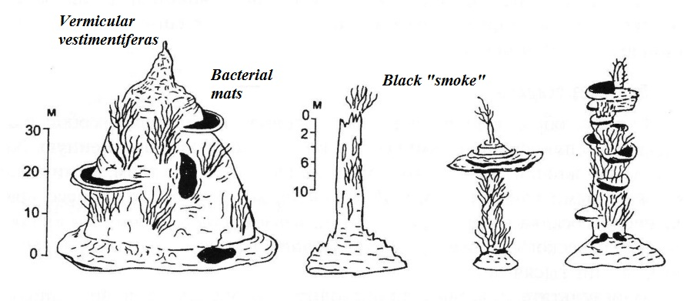
Fig. 6.11. Morphology of high-temperature hydrothermal sulfide structures (Lisicyn and etc., 1990)

