- https://lingualeo.com/ru/?utm_source=ga&utm_medium=cpc&utm_campaign=ru_eng_ill1&utm_content=genlnk&yagla=50038607&gclid=EAIaIQobChMIhITO-Nq35wIVj5IYCh27TQ-lEAAYASAAEgKEAfD_BwE
This is one of the effective sites to improve your English skills

- 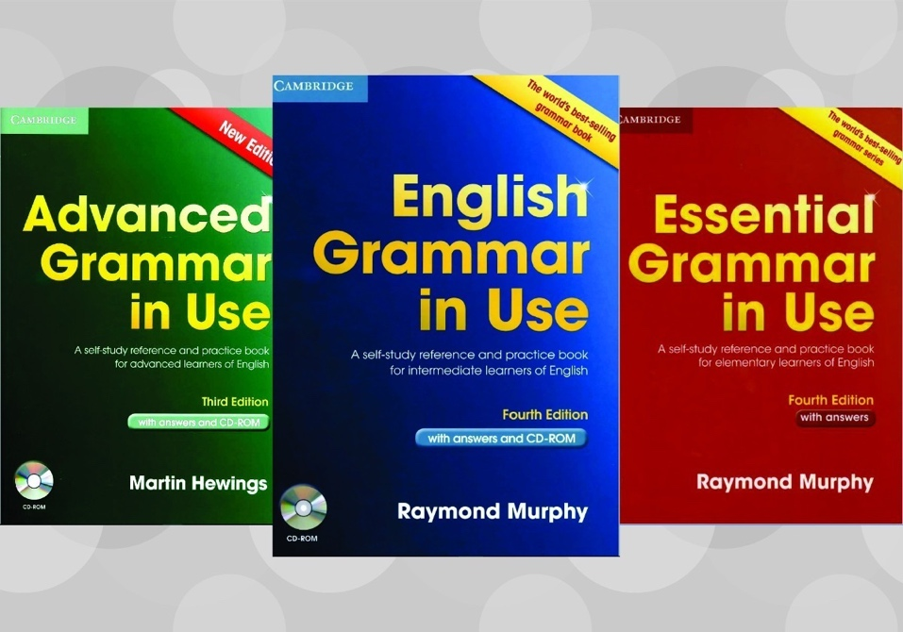

Raymond Murphy

- General websites for students
- MyVoucherCodes.co.uk. ...
- UniDays.com. ...
- WiseBread.com. ...
- Genius.com poetry. ...
- TED.com. ...
- Wikipedia.org. ...
- Bartleby.com. ...
- Gutenberg.org. Similarly, Project Gutenberg provides free online access to texts whose copyright has expired; so far, it's digitized more than 56,000 texts.

